# STEPS TO TURN OFF FIREWALL

1. Open **Windows Defender Firewall.**

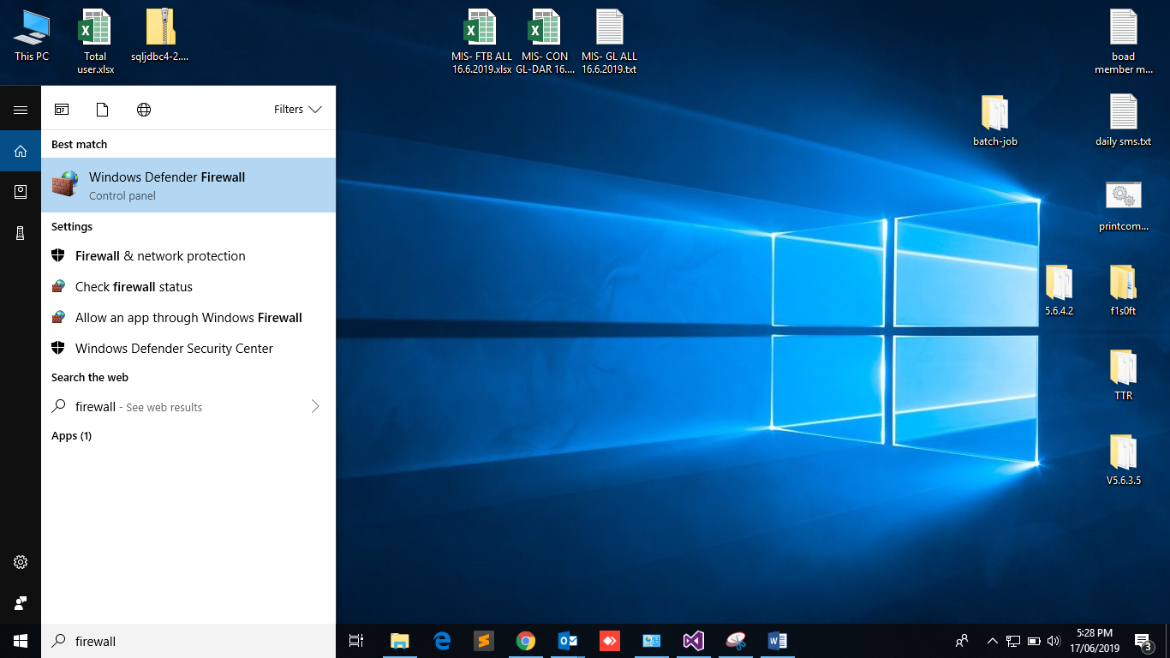

1. Click **Turn** **Windows Defender Firewall on or off.**

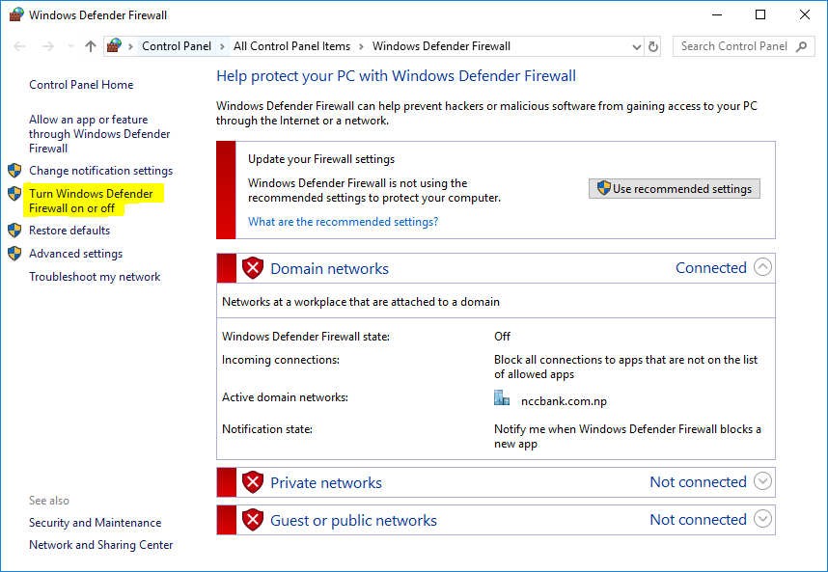

1. Make sure to Turn off all the firewall.

